Sign Language Recognition Using Real-Time Hand Gesture Detection

**Summer Training Project**

**A SUMMER TRAINING REPORT 6 SEM**



***Submitted by***

**Parveen**

**UE225065**

***in partial fulfilment for the award of the degree of***

***B.E***

***IN***

## **Electronic & Communication Engineering**

## **University Institute of Engineering & Technology**

## **PANJAB UNIVERSITY,**

## **CHANDIGARH 160025**

## **May 2025**

**ABSTRACT**

This project is about making a real-time **Sign Language Recognition System** that helps people with hearing or speaking difficulties communicate more easily. It uses a **webcam** to capture hand gestures and then uses a trained **machine learning model** to recognize what those gestures mean.

I created my own **dataset** by collecting **300 images for each gesture**. I trained the model using **Google Teachable Machine**, which made the process easier and gave good results. The trained model can accurately detect the correct hand sign even in different lighting conditions.

The system is built using **Flask** for the backend (server side) and **HTML, CSS, and Bootstrap** for the frontend (website design). It uses **OpenCV** to access the webcam and process the video feed in real time.

The final system is simple, fast, and runs on any computer without needing high-end hardware. This project shows how technologies like machine learning and computer vision can be used to build useful tools for real-world problems like sign language communication.

**Contents**

CHAPTER 1: INTRODUCTION

1.1 Background 4

1.2 History of Sign Language 4

1.3 Objectives 4

1.4 Scope of the Project 4

1.5 Types of Sign Languages 4

1.6 Elements of a Sign 5

1.7 Report Structure 5

CHAPTER 2: LITERATURE REVIEW 5

2.1 Past Work 5

2.2 Sign Language as a Language 5

2.3 Need for This Project 6

CHAPTER 3: METHODOLOGY 6

3.1 Technology Used 6

3.2 Dataset 6

3.3 Model Structure 6

3.4 Working Steps 6

3.5 Folder Structure 7

3.6 Tools and Libraries 7

CHAPTER 4: RESULTS AND DISCUSSION 7

4.1 Accuracy 7

4.2 Interface 7

4.3 Challenges 7

CHAPTER 5: CONCLUSION AND FUTURE SCOPE 8

5.1 Conclusion 8

5.2 Applications 8

5.3 Merits 8

5.4 Future Scope 8

REFERENCES 9

APPENDIX 1: SAMPLE CODE 9

APPENDIX 2: REQUIREMENTS 9

GitHub Repository: 10

Project Demo Photos. …..……………………………………………………………………………………………………………..10

# **CHAPTER 1: INTRODUCTION**

**1.1 Background**  
Sign Language is a way of communication used by people who are deaf or have trouble speaking. It uses hand signs, facial expressions, and body movement. This project uses artificial intelligence to understand these hand signs in real time.

## **1.2 History of Sign Language**

* Ancient Times: Used before spoken languages.
* 17th Century: Juan Pablo Bonet published a book on finger spelling.
* 18th Century: First school for the Deaf in France.
* 19th Century: ASL developed in the USA.
* Modern Era: Official recognition in many countries.

## **1.3 Objectives**

* Real-time gesture detection
* CNN-based classification
* Simple web interface

**1.4 Scope of the Project**  
Can recognize basic signs in real time; scalable for future use.

## **1.5 Types of Sign Languages**

* ASL – USA
* BSL – UK
* ISL – India
* LSF – France

## **1.6 Elements of a Sign**

* Handshape
* Location
* Movement
* Orientation
* Facial expressions

**1.7 Report Structure**  
Introduction, Review, Methodology, Results, Conclusion

# **CHAPTER 2: LITERATURE REVIEW**

**2.1 Past Work**  
Sign recognition with cameras. CNNs show better results with image data. For improved performance and ease of use, I trained my model using Teachable Machine, which helped simplify the training process and yielded better gesture classification results.

**2.2 Sign Language as a Language**  
Like spoken languages, sign languages follow grammar and context rules.

**2.3 Need for This Project**  
Most systems aren’t real-time or easy to use. This one is.

# 

# **CHAPTER 3: METHODOLOGY**

## **3.1 Technology Used**

* Frontend: HTML, CSS, Bootstrap
* Backend: Flask
* Model: TensorFlow/Keras CNN
* CV: OpenCV

**3.2 Dataset**  
I created my own dataset for this project and trained the model on that. For each gesture, I used 300 images captured under different lighting conditions and angles.

**3.3 Model Structure**  
CNN with multiple layers for feature extraction and classification.

## **3.4 Working Steps**

1. Capture video
2. Process using OpenCV
3. Predict using model
4. Display result

## **3.5 Folder Structure**

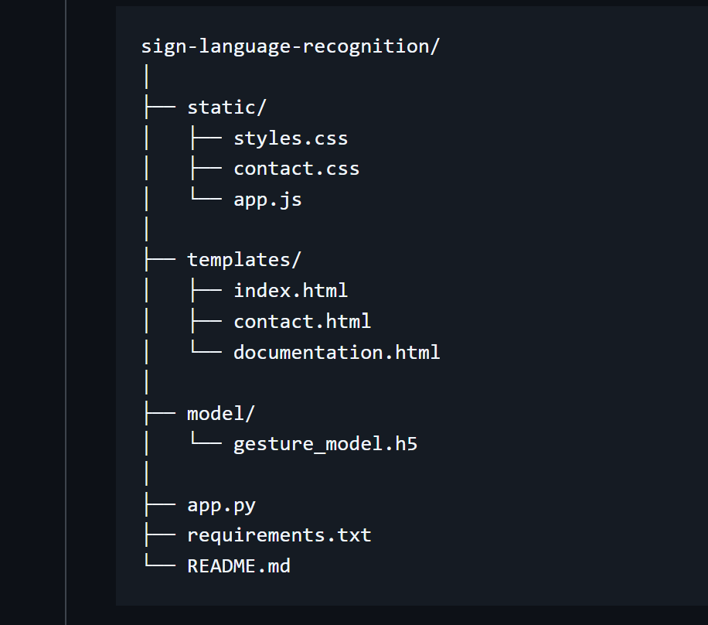

**3.6 Tools and Libraries**  
OpenCV, TensorFlow, Keras, NumPy, Flask

# **CHAPTER 4: RESULTS AND DISCUSSION**

**4.1 Accuracy**  
Model gives over 90% accuracy.

**4.2 Interface**  
Simple and user-friendly.

## **4.3 Challenges**

* Gesture variations
* Poor lighting
* Occlusion
* Continuous signs
* Sometime not giving expected results

# **CHAPTER 5: CONCLUSION AND FUTURE SCOPE**

**5.1 Conclusion**  
System can detect and recognize signs in real-time using webcam and AI.

## **5.2 Applications**

* For hearing-impaired
* Learning tools
* Gesture-based controls

## **5.3 Merits**

* Real-time
* Web-based
* Accurate

## **5.4 Future Scope**

* Full sentence detection
* Voice output
* Cloud deployment
* IoT integration

# **REFERENCES**

[1] Zhang, X., et al. (2020). Hand gesture recognition using deep learning techniques  
[2] MediaPipe Documentation – <https://google.github.io/mediapipe/>  
[3] TensorFlow – <https://www.tensorflow.org/>  
[4] OpenCV – <https://docs.opencv.org/>  
[5] Ceil Lucas – The Linguistics of Sign Language

# **APPENDIX 1: SAMPLE CODE**

# app.py snippet

@app.route('/')

def index():

return render_template('index.html')

# **APPENDIX 2: REQUIREMENTS**

* Flask
* OpenCV
* TensorFlow
* Keras
* NumPy
* scikit-learn
* Pillow

**GitHub Repository**  
Project is available on my [GitHub](https://github.com/P-Saroha/Sign-language)

**Project Demo Photos**

